



**USER MANUAL**

For internal and enterprise users only. Supporting Version:

© 2022 TheFlightSimulations. Creative Update (Beta)

Table of Contents

**Table of contents** 2

**Thank you!** 3

**What’s new?**4

**System Requirements**5

**Installation Guide**6

*Mounting and running the installer6*

*Complete the installation (without SDKs)7*

*Installing the SDKs only (for 64-bit systems)7*

*Manual Installation7*

*Fix the registry7*

*Installing Flight Simulator X: Studio for VTuber 7*

***Installing Creative Update7***

***Installing Creative Update – SDKs only7***

**Download links**9

**Technical Support10**

**User License Agreement (ULA)11**

# Thank you!

We would like to thank you for using ***Flight Simulator X: Studio – Creative Update***.

Even today, ***Microsoft® Flight Simulator®*** is a series of games that has become iconic for Microsoft and Aviation. It was first introduced in **November 1982** and released even before the first version of ***Microsoft®Windows®Operating System***. With a long history, Microsoft was presented lots of *Microsoft® Flight Simulator®*: *Flight Simulator for Win95, Flight Simulator (for Macintosh), Flight Simulator 98, Flight Simulator 2004: A Century of Flight,* and***Flight Simulator X****.*

***Microsoft®Flight Simulator X®***is the tenth installment of the series, released in **October 2006**. It was built on an upgraded DirectX 9.0c rendering engine and the DirectX 10 beta graphic introduced with *Microsoft® Windows Vista®*. It contained everything in the previous version (*Flight Simulator 2004: A Century of Flight)* but with upgrades.

However, even though many developers are still working with Microsoft® Flight Simulator X®, the game still contains unknown bugs (CTO, DirectX error, etc.). It is **incompatible** with **modern devices and OS** (especially Windows 10/11). These bugs affect the experience of your flight in the Flight Simulator.

That’s why we are developing ***Flight Simulator X: Studio****.* We want to make another version of *Microsoft® Flight Simulator X* that is for both development purposes and as a flight simulator. You can run on **the better Flight Simulator** and easily access **SDK Tools**. Furthermore, with ***Flight Simulator X: Studio for VTuber****,* VTuber can stream on the better User Interface.

We hope you – **Insider (or Tester)** – can help us to improve **our Flight Simulator**.

*Thank you, with all respect,*

***TheFlightSimulations Team***

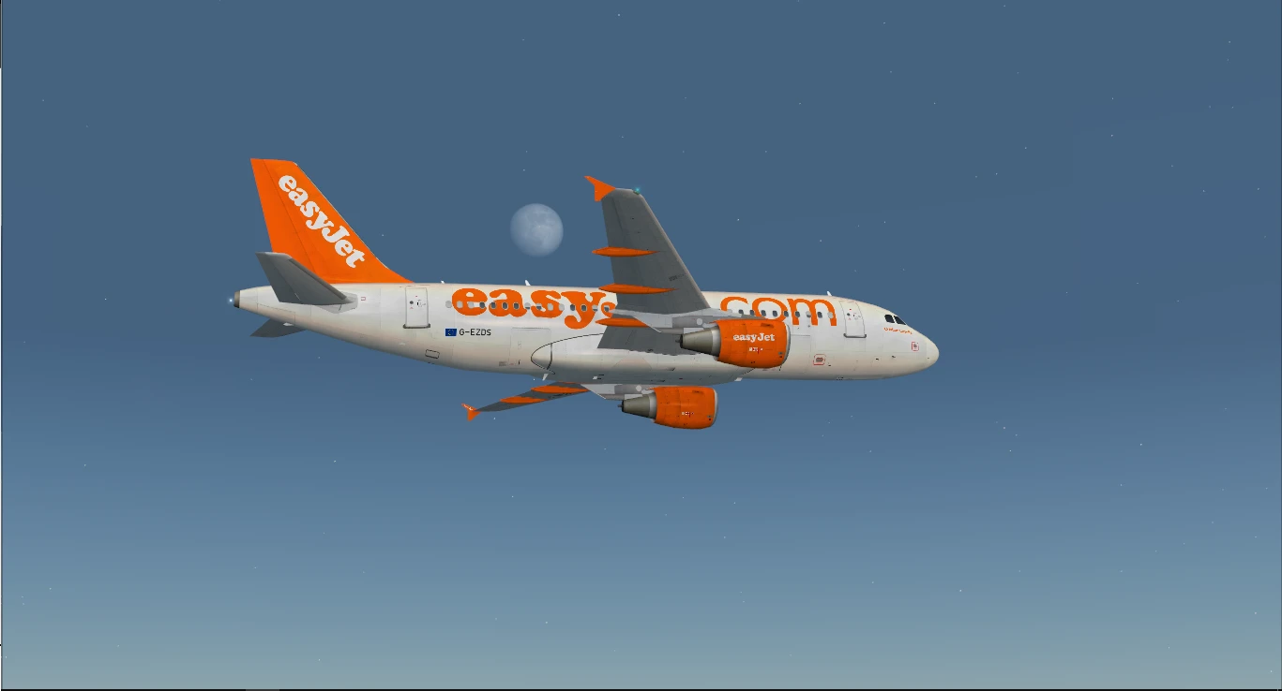

# What’s new?

**Flight Simulator System:**

* New physics system *(Provided by AccuFeel v2)*
* New live world *(Provided by Wildlife+)*
* New effect system *(Provided by TheFlightSimulations, FSFX, and Orbx)*
* New shader *(Provided by Lockheed Martin and TheFlightSimulations)*
* Real-world weather *(Provided by FSXWX.com)*
* New Camera System *(Optional, provided by EZDok)*
* New SimConnect System *(Optional, provided by Pete & John Dowson)*
* New Ground Services *(Optional, provided by FSDreamTeam)*
* New Multiplayer System *(Optional, provided by JoinFS)*
* Flight Planning Tool *(Optional, provided by Aerosoft)*

**Aircrafts:**

* Added 28 aircrafts *(in-game)* + 12 *(optional) + 4 (in Creative Update)*
* Improved default A.I. aircrafts + Added over 300 A.I. aircraft models
* Updated AIRAC and Navigation System *(2106 In initial version, 2206 In initial version)*

**Sceneries:**

* Updated Global Mesh + Vector *(Provided by Orbx and TheFlightSimulations)*
* Detailed Mesh at: Australia, Europe, Northern Rockies, and Pacific NorthWest
* Detailed Cities at: Devils Tower, London, Miami, Portland, San Francisco, Seattle – Tacoma, Tasmania, and Yosemite Valley
* Updated 43 airports to 4K *(details see in* ***“scenery\Reworked\Detailed Airports”****)*
* Updated buildings textures to UHD *(Provided by Orbx)*
* *Fixed metadata at FV76 (in Creative Update, provided by TheFlightSimulations)*

**User Interface:**

* Improved UI *(Provided by TheFlightSimulations)*
* Updated Home. No longer see the “Beta version available” or “No Internet Connection” on the home page *(Provided by FlightPlanDatabase, and TheFlightSimulations)*

# System Requirements

These requirements allow you to run the FS smoothly.

**Note: These are MINIMUM requirements**

**Operating System:** *Windows 10 (64-bit), version 1709 or later*

**CPU:** *Any Intel/AMD CPU faster than Intel Core i3 7200U and has 3.0MB of L3 Cache*

**GPU:** *Any Intel/AMD/NVIDIA GPU faster than NVIDIA GeForce 920MX and support DirectX 10*

**VRAM:** *2GB or more*

**Memory:** *8GB DDR3 or more*

**Disk:**

*+ Required 2GB on local C drive for runtimes and its components*

*+ 190GB on any drive for the main game*

*+ 160GB for download files and virtual disk (.iso) file*

**Additional requirements:**

**+** *dotNet 2.0, dotNet 3.5 and dotNet 4.5 are enabled. For more information about enabling dotNet on Windows 10 1709 or later, see* [*here*](https://docs.microsoft.com/en-us/dotnet/framework/install/dotnet-35-windows)

*+ An stable Internet Connection (to get Real-weather data)*

# Installation Guide

## ***Mounting and running the Installer***

1. *Download all parts and save them into a specific folder.*
2. *Using 7-Zip or WinRAR or any decompressor that supports .rar format. After this, you will have a virtual disk file (FSStudio.iso)*
3. *Mount this virtual disk (using File Explorer or DAEMON Tools Pro). DO NOT extract*
4. *Run the setup file (Install.exe)*

*Note: UAC will ask you about running it as an Administrator. Click “YES” if prompt.*

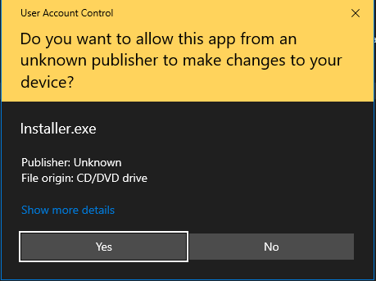

1. *There will be a note and system requirements. However, the requirements are wrong, so ignore that.*
2. *After skipping that, you will get the following commands to continue the installation:*

*+ Complete the installation (with updates, add-ons, and tools; without SDKs)*

*+ Installing the SDKs only (for 64-bit systems only)*

*+ Manual installation*

*+ Exit the Installer*

*+ Fix the registry*

*+ Installing Flight Simulator X: Studio for VTuber*

## ***Complete the installation (without SDKs)***

1. *Press “1” on your keyboard. A pop-up window will ask you to fill the path you want to install the Flight Simulator X: Studio.*

*Note 1: Your path should not include these following characters: * : ? "< > |. Except the drive letter should have “:” (C: D: E: ).*

*Note 2: You’d need to close* ***ALL FORCEGROUND PROGRAMS AND OTHER INSTALLERS*** *and ensure no installer* ***is running*** *during the installation.*

Figure 1: In this picture, the FS will be installed to "F:\Flight Simulator X Studio\Main", in which "F:" is the drive letter.

1. *Press Enter to let the Installer continue. Depending on your disk speed transfer rate, the installation will happen in around 2 – 18 hours.*
2. *At the end of the installation, the Installer will install optional components, such as Ground Services and Airplanes. Just follow the instructions on the Installer window.*
3. *Done. You’ve installed Flight Simulator X: Studio. However, the Creative has not been installed, so please see how to install it here.*

## ***Installing the SDKs only (for 64-bit systems only)***

1. *Press “2” on your keyboard. A pop-up window will ask you to fill the path you want to install the Flight Simulator X: Studio SDKs.*

*Note 1: Your path should not include these following characters: * : ? "< > |. Except the drive letter should have “:” (C: D: E: ).*

*Note 2: You’d need to close* ***ALL FORCEGROUND PROGRAMS AND OTHER INSTALLERS*** *and ensure no installer* ***is running*** *during the installation.*

1. *Just follow the instruction on the Installer window.*

## ***Manual Installation***

1. *Press “3” on your keyboard. A pop-up window will ask you to fill the path you want to do manual installation. Whenever it asks about Flight Simulator’s path, just fill them correctly, especially if it asks you to fill in where the FS is installed.*

*Note 1: Your path should not include these following characters: * : ? "< > |. Except the drive letter should have “:” (C: D: E: ).*

*Note 2: You’d need to close* ***ALL FORCEGROUND PROGRAMS AND OTHER INSTALLERS*** *and ensure no installer* ***is running*** *during the installation.*

1. *The Installer was designed to guide you every time you go, and each option is separate from another, so we cannot write them down here.*

## ***Fix the registry***

*Sometimes, you may get an error whenever you want to install any third-party add-ons.*

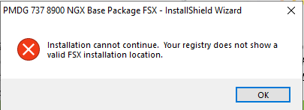

*This option will fix this error: just fill your FS path into them.*

*Note 1: Your path should not include these following characters: * : ? "< > |. Except the drive letter should have “:” (C: D: E: ).*

*Note 2: You’d need to close* ***ALL FORCEGROUND PROGRAMS AND OTHER INSTALLERS*** *and ensure no installer* ***is running*** *during the installation.*

## ***Installing Flight Simulator X: Studio for VTuber***

*Contact your Contributor or your Organization to get the installation key.*

*(Internet connection required)*

## ***Installing Creative Update***

*As the same as the “Complete the installation (with updates, add-ons, and tools; without SDKs).”*

## ***Installing Creative Update - SDKs***

*As the same as the “Installing the SDKs only (for 64-bit systems only)”*

# Download links

*Please contact your OEM or your organization to get this package.*

# Technical Support

*Should you have any questions about our new Flight Simulator, or want to report bugs, feel free to contact us via:*

***Email:*** [*theflightsimulations@gmail.com*](mailto:theflightsimulations@gmail.com)

***Discord:*** [*Join here*](discord.gg/VdbJAHKhuW)

*Note: The support request via email requires title:* ***[SUPPORT REQ] + Problem***

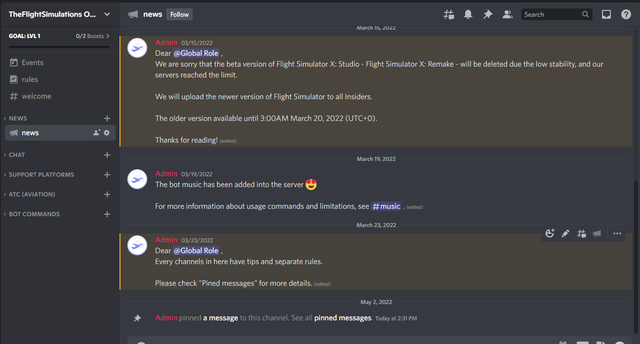

# User License Agreements (ULA)

*This ULA pertains to TheFlightSimulations Products (in this case, Flight Simulator X: Studio) that we provide to you via your Contributor, your Organization, or electric documentation. Please read the terms and conditions of this ULA before using it or publishing it.*

*This ULA is a legally enforceable contract between you ("Customer", or "Publisher", or “Organization”, or "Contributor") and TheFlightSimulations Team (or "TheFlightSimulations”).*

*1. You ("Customer", or "under your Organization"; not a “Contributor”, or “Publisher”, or “Organization”) only have the following permissions to use this product:*

***+ Copy & Publish:*** *RESTRICTED (Requires permission from your Organization or TheFlightSimulations)*

***+ Distribution:*** *RESTRICTED (Requires permission from your Organization or TheFlightSimulations)*

***+ Commercial Use:*** *NOT ALLOWED*

***+ Modify & Adapt:*** *NOT ALLOWED*

***+ Change license:*** *NOT ALLOWED*

***+ Personal Use:*** *only for you, and only installed on your devices, not on devices that are not yours)*

*2. You ("Customer", or a “Contributor”, or “Publisher”, or “Organization”) only have the following permissions to use this product:*

***+ Copy & Publish:*** *RESTRICTED (Requires permission from TheFlightSimulations)*

***+ Distribution:*** *YES*

***+ Commercial Use:*** *YES*

***+ Modify & Adapt:*** *YES. But only under control. Future updates may break your modifications.*

***+ Change license:*** *YES*

*3.* *Flight Simulator X: Studio and related documentation are licensed, not sold. Any rights not clearly and expressly granted to you under this ULA are reserved for TheFlightSimulations. Provided you registered the Software with TheFlightSimulations, and otherwise complied with this ULA, TheFlightSimulations gives you the following non-exclusive, non-transferable, limited rights:*

*a) You may not lease, rent or otherwise charge for any person to use the Software, a computer running the Software, or a device that uses the Software without first obtaining an appropriate license from TheFlightSimulations.*

*b) You may not operate this Software in a public venue designed to demonstrate hardware or other display, sound, processing, or simulation components without the express permission of TheFlightSimulations.*

*c) You may not charge non-licensed or licensed owners of this Software for the use of this Software, training in conjunction with this Software, or while using this Software to demonstrate any technique or process that may be considered training or familiarization except as described in this license.*

*d) If you create an application designed to interact with this Software, you may manipulate or control the Software using only the expressly provided methods included in this license.*

*e) TheFlightSimulations reserves any rights not explicitly given to you in this ULA.*

*End of document*

*Written by Co-Founder of TheFlightSimulations*